BIG DATA ANALYTICS

EXPERIMENT 2[1]

### Define Linux, Linux Distribution, Difference between Linux and Ubuntu, Features of Ubuntu

## Sol:

## What is Linux?

**LINUX** is an operating system or a kernel distributed under an open-source license. Its functionality list is quite like UNIX. The kernel is a program at the heart of the Linux operating system that takes care of fundamental stuff, like letting hardware communicate with software.

[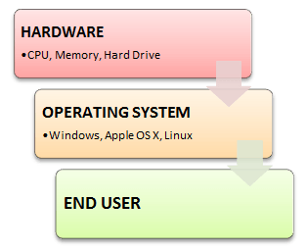](https://www.guru99.com/images/OperatingSystemBasics.png)

## Why do you need an OS?

Every time you switch on your computer, you see a screen where you can perform different activities like write, browse the internet or watch a video. What is it that makes the computer hardware work like that? How does the processor on your computer know that you are asking it to run an mp3 file? Well, it is the operating system or the kernel which does this work. So, to work on your computer, you need an Operating System (OS). In fact, you are using one as you read this on your computer. Now, you may have used popular OS's like Windows, Apple OS X, but here we will learn introduction to Linux operating system, Linux overview and what benefits it offers over other OS choice

**Who created Linux?**

Linux is an operating system or a kernel which germinated as an idea in the mind of young and bright **Linus Thorvaldsen** when he was a computer science student. He used to work on the **UNIX OS (proprietary software)**and thought that it needed improvements.

However, when his suggestions were rejected by the designers of UNIX, he thought of launching an OS which will be **receptive to changes, modifications suggested by its users**.

## The Lone Kernel & the early days

So **Linus devised a Kernel** named Linux in 1991. Though he would need programs like File Manager, Document Editors, and Audio -Video programs to run on it. Something as you have a cone but no ice-cream on top. As time passed by, he collaborated with other **programmers in places like MIT** and applications for Linux started to appear. So around 1991, a working Linux operating system with some applications was officially launched, and this was the start of one of the **most loved and open-source OS options available today**. The earlier versions of Linux OS were not so user-friendly as they were in use by computer programmers and **Linus Thorvaldsen never had it in mind to commercialize** his product. This definitely curbed the Linux's popularity as other commercially oriented Operating System Windows got famous. Nonetheless, the open-source aspect of the Linux operating system made it more robust.

## Linux gets its due attention

[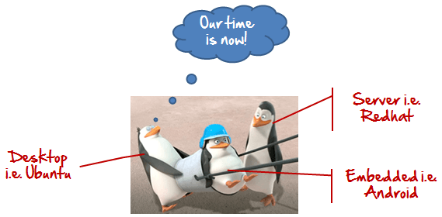](https://www.guru99.com/images/OurTimeIsNow.png)

The main advantage of Linux was that programmers were able to use the Linux Kernel to design their own custom operating systems. With time, a new range of user-friendly OS's stormed the computer world. Now, **Linux is one of the most popular and widely used Kernels,**and it is the backbone of popular operating systems like **Debian, Knoppix, Ubuntu, and Fedora**. Nevertheless, the list does not end here as there are thousands of Best versions of Linux OS based on the Linux Kernel available which offer a variety of functions to the users.

Linux Kernel is normally used in combination of GNU project by Dr. Richard Stallman. All modern distributions of Linux are actually distributions of Linux/GNU

## The benefits of using Linux

Linux OS now enjoys popularity at its prime, and it's famous among programmers as well as regular computer users around the world. Its main benefits are - It offers a **free operating system**. You do not have to shell hundreds of dollars to get the OS like Windows!

[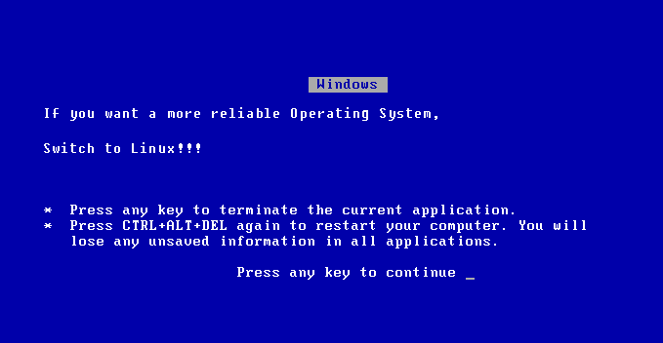](https://www.guru99.com/images/Linux_Windows_Error.png)

* Being open-source, anyone with programming knowledge can modify it.
* It is easy to learn Linux for beginners
* The Linux operating systems now offer **millions of programs/applications and Linux software’s to choose from**, most of them are free!
* Once you have Linux installed you no longer need an antivirus! Linux is a highly secure system. More so, there is a global development community constantly looking at ways to enhance its security. With each upgrade, the OS becomes more secure and robust
* Linux freeware is the OS of choice for Server environments due to its stability and reliability (Mega-companies like Amazon, Facebook, and Google use Linux for their Servers). A Linux based server could run non-stop without a reboot for years on end.

## Is it for me?

[](https://www.guru99.com/images/Should_I_Use_IT.png)

Users, who are new to Linux, usually shun it by falsely considering it as a difficult and technical OS to operate but, to state the truth, in the last few years Linux operating systems have become a lot more user-friendly than their counterparts like Windows**,** so trying them is the best way to know whether Linux suits you or not. There are **thousands of Best Linux OSs** and Linux software’s available based on the Linux Kernel; most of them offer **state-of-the-art security and applications**,**all of it for free!** This is what Linux is all about, and now we will move on to how to install Linux and which Distribution you should choose. UNIX is called the mother of operating systems which laid out the foundation to Linux. UNIX is designed mainly for mainframes and is in enterprises and universities. While Linux is fast becoming a household name for computer users, developers, and server environment. You may have to pay for a UNIX kernel while in Linux it is free. But, the **commands used on both the operating systems are usually the same.** There is not much difference between UNIX and Linux. Though they might seem different, at the core, they are essentially the same. Since **Linux is a clone of UNIX**. So learning one is same as learning another

**Introduction to Linux Operating System**

* Difficulty Level : Basic
* Last Updated : 09 Sep, 2020

Linux is a community of open-source UNIX like operating systems that are based on the Linux Kernel. It was initially released by **Linus Thorvaldsen** on September 17, 1991. It is a free and open-source operating system and the source code can be modified and distributed to anyone commercially or non commercially under the GNU General Public License.   
Initially, Linux was created for personal computers and gradually it was used in other machines like servers, mainframe computers, supercomputers, etc. Nowadays, Linux is also used in embedded systems like routers, automation controls, televisions, digital video recorders, video game consoles, smart watches, etc. The biggest success of Linux is Android (operating system) it is based on the Linux kernel that is running on smart phones and tablets. Due to android Linux has the largest installed base of all general-purpose operating systems. Linux is generally packaged in a Linux distribution.

### Linux Distribution

Linux distribution is an operating system that is made up of a collection of software based on Linux kernel or you can say distribution contains the Linux kernel and supporting libraries and software. And you can get Linux based operating system by downloading one of the Linux distributions and these distributions are available for different types of devices like embedded devices, personal computers, etc. Around **600 + Linux Distributions** are available and some of the popular Linux distributions are:

* MX Linux
* Manjaro
* Linux Mint
* elementary
* Ubuntu
* Debian
* Solus
* Fedora
* Open SUSE
* Deepin

### Architecture of Linux

Linux architecture has the following components:

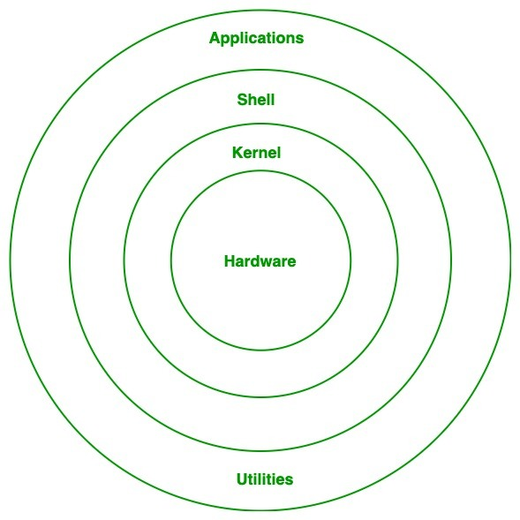

1. **Kernel:**Kernel is the core of the Linux based operating system. It virtualizes the common hardware resources of the computer to provide each process with its virtual resources. This makes the process seem as if it is the sole process running on the machine. The kernel is also responsible for preventing and mitigating conflicts between different processes. Different types of the kernel are:
   * Monolithic Kernel
   * Hybrid kernels
   * Exo kernels
   * Micro kernels
2. **System Library: Is**the special types of functions that are used to implement the functionality of the operating system.
3. **Shell:**It is an interface to the kernel which hides the complexity of the kernel’s functions from the users. It takes commands from the user and executes the kernel’s functions.
4. **Hardware Layer:**This layer consists all peripheral devices like RAM/ HDD/ CPU etc.
5. **System Utility:**It provides the functionalities of an operating system to the user.

### Advantages of Linux

* The main advantage of Linux is it is an open-source operating system. This means the source code is easily available for everyone and you are allowed to contribute, modify and distribute the code to anyone without any permission.
* In terms of security, Linux is more secure than any other operating system. It does not mean that Linux is 100 percent secure it has some malware for it but is less vulnerable than any other operating system. So, it does not require any anti-virus software.
* The software updates in Linux are easy and frequent.
* Various Linux distributions are available so that you can use them according to your requirements or according to your taste.
* Linux is freely available to use on the internet.
* It has large community support.
* It provides high stability. It rarely slows down or freezes and there is no need to reboot it after a short time.
* It maintains the privacy of the user.
* The performance of the Linux system is much higher than other operating systems. It allows a large number of people to work at the same time and it handles them efficiently.
* It is network friendly.
* The flexibility of Linux is high. There is no need to install a complete Linux suit; you are allowed to install only required components.
* Linux is compatible with a large number of file formats.
* It is fast and easy to install from the web. It can also install on any hardware even on your old computer system.
* It performs all tasks properly even if it has limited space on the hard disk.

### Disadvantages of Linux

* It is not very user-friendly. So, it may be confusing for beginners.
* It has small peripheral hardware drivers as compared to windows.

**Is There Any Difference between Linux and Ubuntu?**

The answer is YES. The main difference between Linux and Ubuntu is Linux is the family of open-source operating systems which is based on Linux kernel, whereas Ubuntu is a free open-source operating system and the Linux distribution which is based on Debian. Or in other words, Linux is the core system and Ubuntu is the distribution of Linux. Linux is developed by Linus Thorvaldsen and released in 1991 and Ubuntu is developed by Canonical Ltd. and released in 2004.  
 Ubuntu is a Linux-based operating system. It is designed for computers, smart phones, and network servers. The system is developed by a UK based company called Canonical Ltd. All the principles used to develop the Ubuntu software are based on the principles of Open Source software development.

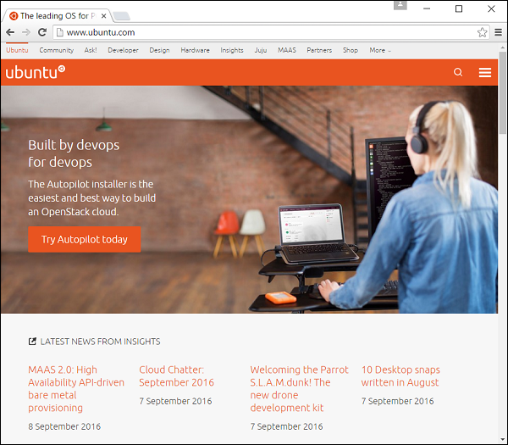

## Features of Ubuntu

Following are some of the significant features of Ubuntu −

* The desktop version of Ubuntu supports all the normal software on Windows such as Firefox, Chrome, VLC, etc.
* It supports the office suite called **Libre Office**.
* Ubuntu has an in-built email software called Thunderbird, which gives the user access to email such as Exchange, Gmail, Hotmail, etc.
* There are a host of free applications for users to view and edit photos.
* There are also applications to manage videos and it also allows the users to share videos.
* It is easy to find content on Ubuntu with the smart searching facility.
* The best feature is, it is a free operating system and is backed by a huge open source community.

**Release Cycle of Ubuntu**

Every year there are 2 releases of Ubuntu, one in April and one in October, from Canonical. The version number normally denotes the year in which the software was released. For example, version 14.04 specifies that it was released in the year 2014 and in the month of April. Similarly, the version 16.04 specifies that it was released in the year 2016 and in the month of April. The April build every year is the more stable build, while the October build does a lot of experimentation on new features.

The official site for Ubuntu is <https://www.ubuntu.com/>

The site has all information and documentation about the Ubuntu Software. It also has the download links for both the server and desktop versions of Ubuntu. We need to ensure we have the right hardware specifications in order to have Ubuntu installed.

## System Requirements

**Ensure the following system requirements are met before proceeding with the installation.**

|  |  |
| --- | --- |
| **Memory** | **2GB RAM (recommended)** |
| **Disk Space** | **25GB of free hard disk space** |
| **Processor** | **2 GHz dual core processor or better** |
| **Other requirements** | **An optional DVD drive or USB drive with the Installer media. An internet connection to download the optional updates.** |

## Downloading Ubuntu

**Step 1** − to download Ubuntu, go to the following URL − https://www.ubuntu.com/download/desktop

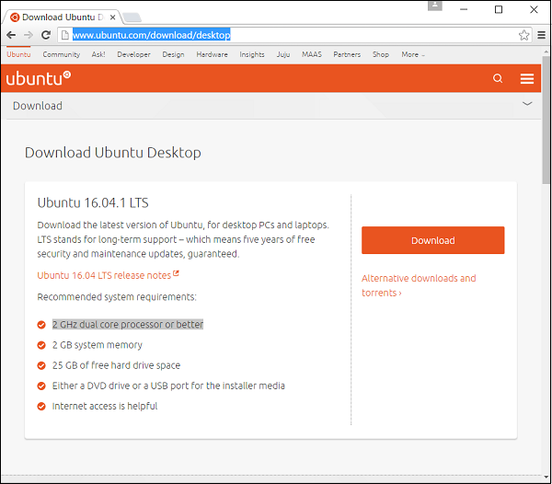

**Step 2** − on this page, there is an option to download the older versions of Ubuntu if required. Click the Alternative downloads and torrents link.

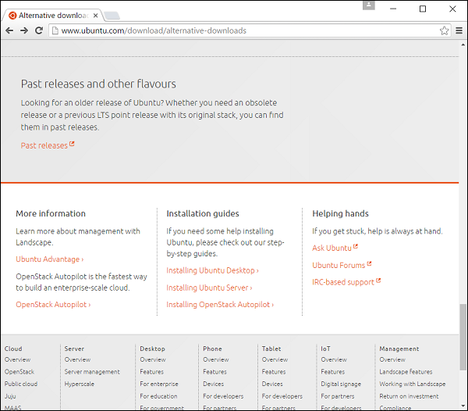

**Step 3** − Go to Past releases link. It then presents a page with all the past releases of the Ubuntu software.

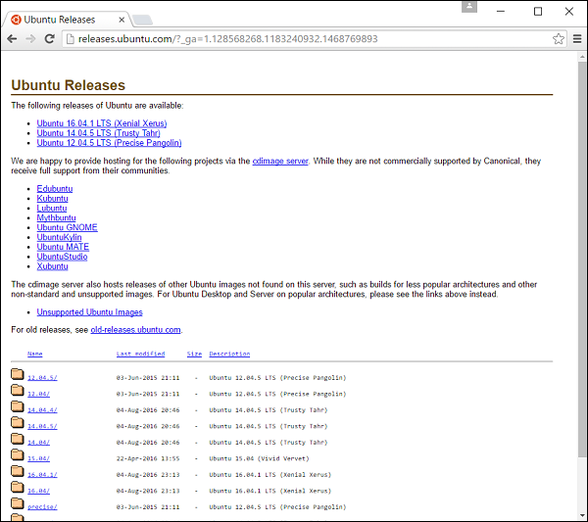

## Installing Ubuntu

Now let’s learn about installing the desktop version of Ubuntu. For the purpose of this tutorial, we will go with the latest version which is 16.04. The installer is a ISO image which can be mounted on a DVD drive or USB stick. Once the image is booted on the machine, following are the steps for installation.

**Step 1** − the first screen allows us to either install or try out Ubuntu. The try out option allows us to see the features of Ubuntu without actually installing it. However, we want to use Ubuntu, so let’s choose the Install Ubuntu option.

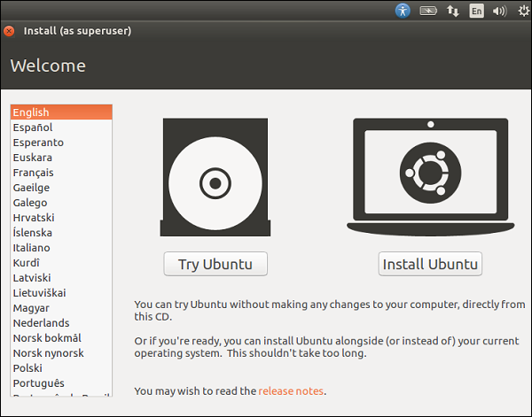

**Step 2** − The next screen gives you 2 options. One is to download updates in the background while installing and the other is to install 3rd party software. Check the option to install 3rd party software. Then click the Continue button.

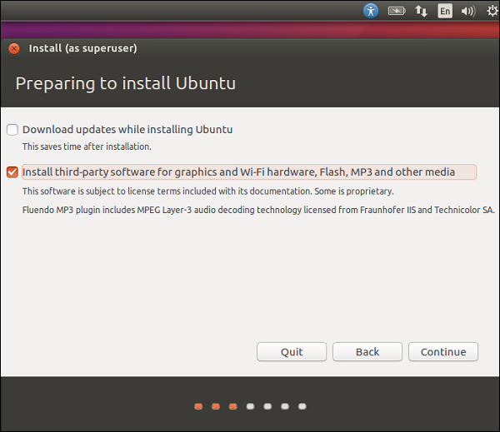

**Step 3** − in the next screen, the following options are presented −

* The disk is erased and the installation is carried out. If there was another operating system already on the disk, then Ubuntu would detect it and give the user the option to install the operating system side by side.
* There is an option to encrypt the installation. This is so that if anybody else were to steal the data, they would not be able to decrypt the data.
* Finally, Linux offers a facility called LVM, which can be used for taking snapshots of the disk.

For the moment, to make the installation simple, let’s keep the options unchecked and proceed with the installation by clicking the Install Now button.

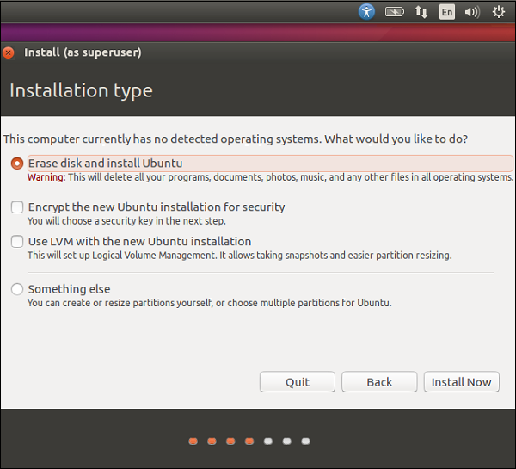

**Step 4** − in the following screen, we will be prompted if we want to erase the disk. Click the Continue button to proceed.

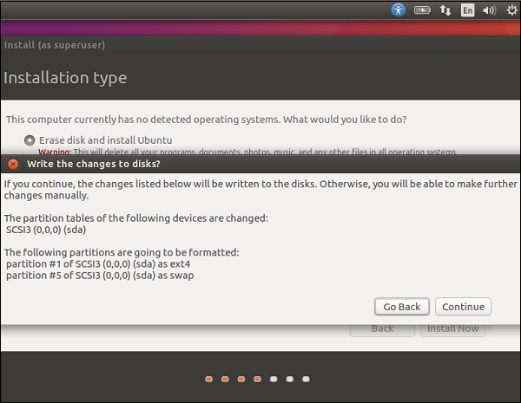

**Step 5** − in this screen, we will be asked to confirm our location. Click the Continue button to proceed.

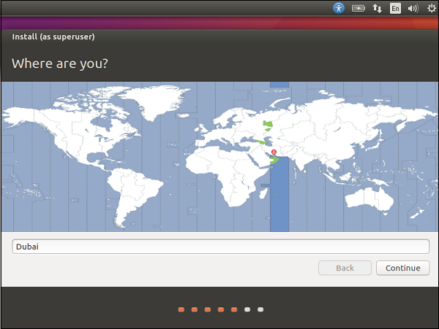

**Step 6** − Now, we will be asked to confirm the language and the keyboard settings. Let us select English (UK) as the preferred settings.

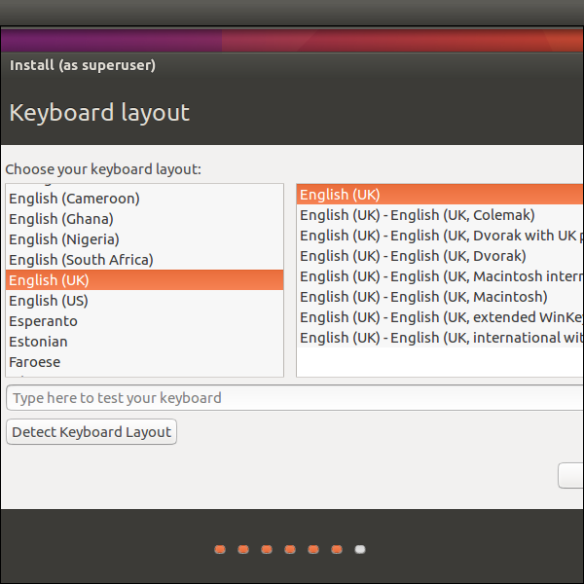

**Step 7** − in the following screen, we will need to enter the user name, computer name and password which will be used to log into the system. Fill the necessary details as shown in the following screenshot. Then, click the continue button to proceed.

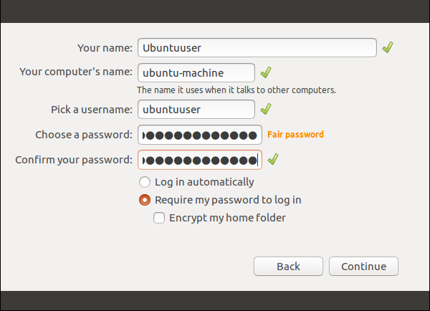

The system will now proceed with the installation and we will see the progress of the installation as shown in the following screenshot.

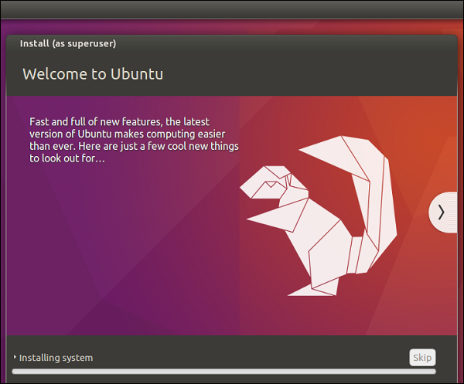

At the end of the installation, the system will prompt for a restart.

**Step 8** − Click the Restart Now to proceed.

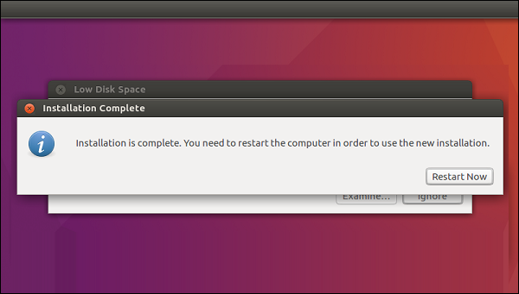

Once the restart is complete, log in with the username and password.

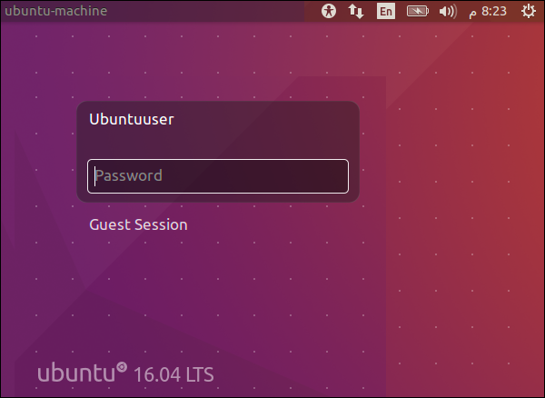

Once logged in, the desktop is presented as shown in the following screenshot.

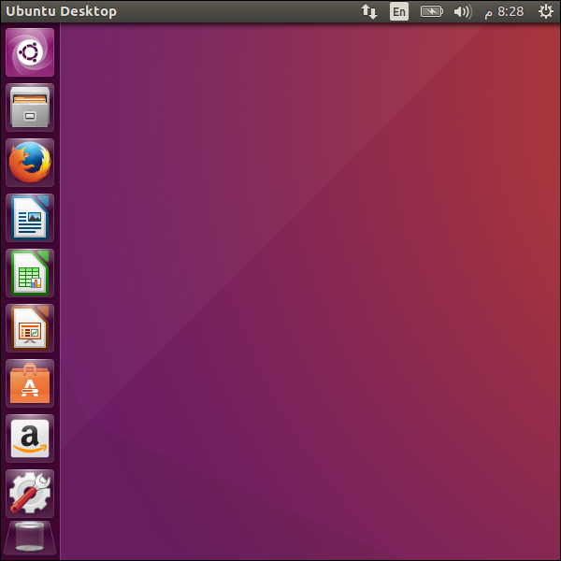

We now have a fully functional version of Ubuntu. In the subsequent chapters, we will look at the various features available.

Let us take a quick look at the Ubuntu environment before we proceed ahead with the remaining chapters.

### The Control Panel

The Control Panel on the left-hand side of the screen presents shortcuts for all of the most used applications. Using these options, we can launch the Libre Office component, the Firefox browser, the Software Center and many other applications.

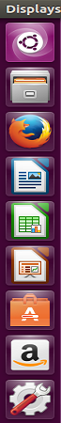

### The Menu Bar

When we launch any application, we will get the associated menu bar at the top of the application, which will have the different menu options for that application. We can choose to close the entire window or resize the window, if required.

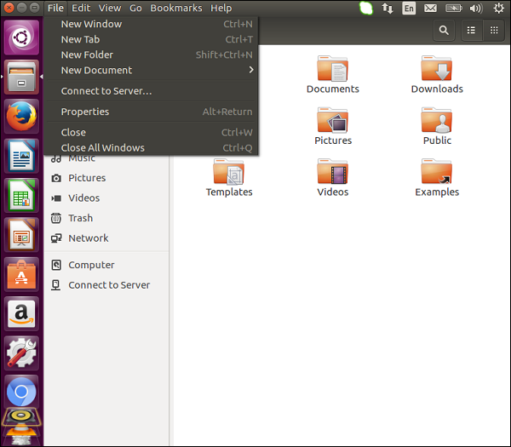

### Taskbar

On the right-hand side of the screen is the task bar. The taskbar allows us to choose the change in volume settings, view the status of your internet connect, change your language and other settings, and view the battery status while working on a laptop.

Ubuntu comes in a variety of flavors. In this chapter, we will discuss briefly about some of the popular flavors of Ubuntu.

## Ubuntu Desktop

This is the operating system which can be used by regular users. This comes pre-built with software that help the users perform usual basic activities. Operations such as browsing, email and multimedia are also available in this edition. The latest version as of September 2016 is 16.04.01.

## Ubuntu Server

The server version is used for hosting applications such as web servers and databases. Each server version is supported by Ubuntu for 5 years. These operating systems have support for cloud platforms such as AWS and Azure. The latest version as of September 2016 is 16.04.1.

## Kubuntu

The normal Ubuntu interface is based on software called Unity. However, Kubuntu is based on software called KDE Plasma desktop. This gives a different look and feel to the Ubuntu software. Kubuntu has the same features and software availability as Ubuntu. The official site for Kubuntu is https://www.kubuntu.org/

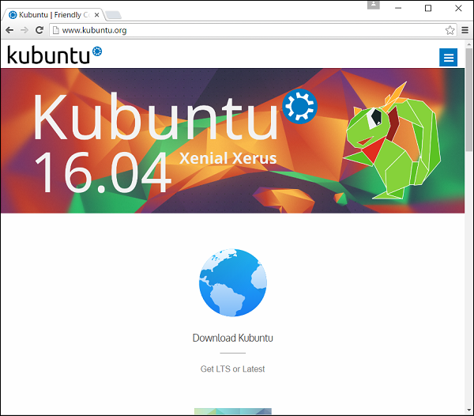

## Linux Mint

This is also based of the Ubuntu operating system. It comes pre-built with a lot of applications for the modern user in the space of photos and multimedia. This operating system is completely based on the open source community.

The official site for Linux Mint is https://www.linuxmint.com/

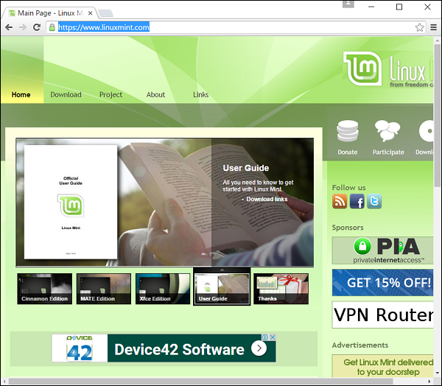

By default, Ubuntu comes with pre-built required drivers for the mouse, keyboard, audio and video drivers. Long gone are the days where device drivers used to be a nightmare for Linux-based operating systems.

To view the options for devices, go to the settings options on the left-hand side control panel.

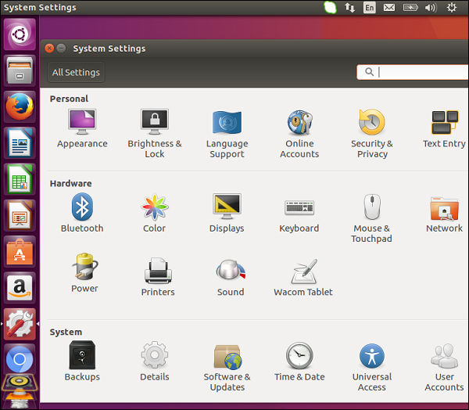

In the hardware section, you will see the various options for the hardware devices such as the display monitor, keyboard, mouse, etc.

For example, using the Display section, we can change the resolution of the screen along with other display settings as shown in the following screenshot.

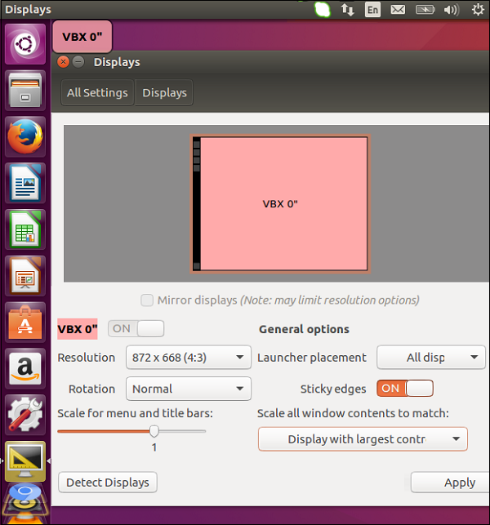

To install any additional drivers, we need to go to the respective driver website and download the necessary distribution for the particular device driver. Then, use the Software Center to install the required device driver.